
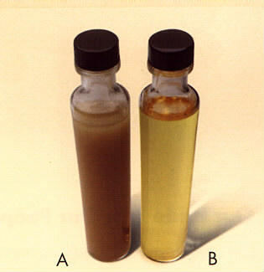
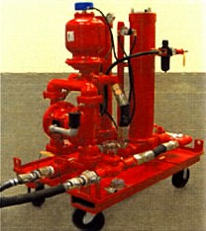
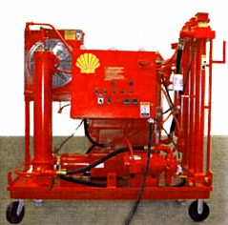
- CCraC

FOR YOUR ONE INDUSTRIAL SOLUTION

CALL
1-800
451- 5823

Presenting…….

SHELL….INDUSTRIAL LINEUP

Chain Drive Oils – Various Types
- Circulating Oils – For your Equipment Needs
- Compressor Oils – Synthetic + Mineral Oil Based
- Greases – Includes: Food Grade, Trucking, Rail Road, Industrial + Aviation

- Heat Transfer Oils – High Temperature

- Hydraulic Oils – Premium, AW, Non-Zinc, Fire Resistant, Aviation, Food Grade, Biodegradable + Synthetic

- Metal Working Fluids – Shell + D.A. Stuart Products
- Refrigeration Oils – Highly Refined Base Stocks
- Transformer Oils – Product You can Trust
- Turbine Oils – Long-lasting
- Cleaners – Non-slip Floor + Systems
- Variety of Container Sizes + Bulk

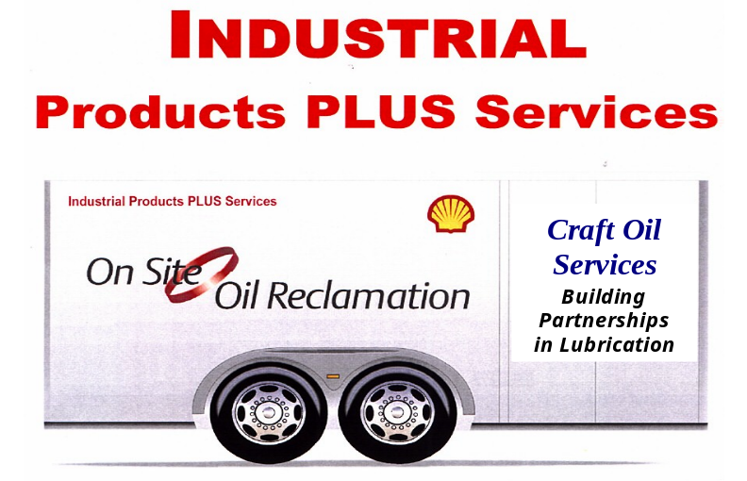

Equipment Surveys

Lubrication Management Software

Oil Sampling + Analysis

Reclamation / Fluid Reconditioning

Fluid Monitoring + System Check

Lubrication Manpower / Site Management
Doesn’t Your Equipment Deserve the Best?

Craft Oil Services

839 Cherry St., Avoca, PA 18641

1-800-451-5823

